Project scope and plan

Project name
Research field

Principal Investigator (PI)
Title (Dr., Prof., etc.)
Last name
First name
Organisation name*
Department*
Group*
Country
*Example:
- University of Zurich
- Department of Physics
- Molecular Physics Group

Co-PIs (same information)
Provide the details of any Co-PIs in the project, including Title, Last name, First name, Organisation, Department, Group and Country.

It is mandatory to include all team members.

IMPORTANT NOTICE
All of the sections and subsections below MUST BE COMPLETED (unless stated otherwise). In case you wish to leave a section empty, please provide a reason. The Scientific Advisory Committee (SAC) will not be able to process proposals that neither provide the requested information nor a justification for the lack of such information for each section.
The structure and formatting settings of this template must be preserved and respected (change in font size or margin and spacing settings are not allowed). The maximum number of pages allowed is 20 pages, including graphs, tables and references, but not counting the cover page and the appendix. Reviewers will be instructed not to consider any pages out of the limit. Applicants are requested to include information about their track record in Appendix 1 at the end of the document (not counted in the page limit). Instruction paragraphs can be removed from the proposal text.
Upload a single document for the project, based on the present template, in PDF format without exceeding 8 MB.
Proposals that do not follow the template or that are incomplete will be administratively rejected and will not be further evaluated.

Key scientific/societal/technological contribution of the proposal (200 words max.)
Outline the scientific/societal/technological importance of your project, how high performance computing (HPC) will help you achieve your goals and what the major expected outcomes are. This section would typically be the same as an abstract of your proposal.
<Enter your text here>

Detailed proposal information (maximum 14 pages, graphs and tables included)
The information should be suitable for expert peer review in your discipline. It must also have appropriate information for a broader audience as your proposal will be evaluated by a panel and in parallel with proposals in other disciplines.

Justification for the importance of the scientific problem and the requested resources (~2 pages)
Describe the proposed research and the main scientific/technical advances you will achieve with the requested CHRONOS allocation. The justification of the requested resources must be clearly linked to the software performance evaluation (Section 2.6).
<Enter your text here>

Overview of the project (~4 pages)
Describe the motivation, objectives and scientific challenges of the problem. Describe and justify the choice of computational methods. State the advances that will be enabled through the requested CHRONOS Tier-0 award (e.g., impact on community paradigms, valuable insights or solving a long-standing challenge, new technology/therapy, etc.). Provide a list of expected outcomes of your proposal and, if relevant, the interdisciplinary value of your proposal.
<Enter your text here>

Validation, verification, state of the art (~2 pages)
Please describe the validity of the simulations and predictions made with this proposal. In case you provide references to relevant publications please include here also the key relevant results. Please address issues of reproducibility and highlight the predictive capabilities of your simulations.

Validation
Validate your model against experiments or other established reference data.
<Enter your text here>

Verification
Verify the numerical consistency of your method or provide evidence of existing verifications.
<Enter your text here>

Sensitivity analysis and uncertainty quantification
Provide sensitivity analysis of your method. Provide estimates of the uncertainty of your predictions. Data driven uncertainty quantification is encouraged. In case of multiphysics/multiscale problems, uncertainty of the full methods and software is desirable.
<Enter your text here>

Comparison with state of the art
Place the project in the context of competing work. Explain the relative advantages AND drawbacks of your approach.
<Enter your text here>

Software and Attributes (~2 pages)
(Please see also Examples of Performance Reporting in Section 2.6.2.1). Describe the software that will be used including a discussion of the state of the art in the field. The description should mention:

<Enter your text here>

Software
Please describe all codes you are using in the proposal. Justify your choices and describe alternatives (if any).
<Enter your text here>

Particular libraries
Describe particular libraries required by the production and analysis software, algorithms and numerical techniques employed (e.g., finite element, iterative solver), programming languages. Please specify requirements for compilation or build environment (build system (e.g., cmake, python version), version control system (e.g., git, subversion) etc.).
<Enter your text here>

Parallel programming
Model(s) used (e.g., MPI, OpenMP/Pthreads, CUDA, OpenACC, etc.).
<Enter your text here>

I/O requirements
I/O requirements (e.g., amount, size, bandwidth, etc.) for execution, input files, restart and other output. Describe I/O strategy (number of files, frequency, read/write size) and I/O behaviour of your code during the period of calculations. Please specify the restart overhead, not only for I/O; (e.g., a code may have to perform a costly domain decomposition first).
<Enter your text here>

Data: Management Plan, Storage, Analysis and Visualization (~1 page)

Data Management Plan covering
Data Management Plan covering both short-term and long-term aspects, including needs for I/O bandwidth, number of files and input/output data volumes. Specify how long the data must be stored at the computing centre after the termination of the project, how it will be moved from the centre, and how subsequent analysis will be performed. Specify the availability of both code and data to other researchers, and how this will be handled.
<Enter your text here>

Project workflow
Project workflow including the role and timeline of data analysis and visualization identify where the analysis will be done and any potential bottlenecks in the analysis process. Describe any analysis and/or data reduction tools used.
<Enter your text here>

Software workflow solution
Software workflow solution (e.g., pre- and post-processing scripts that automate run management and analysis) to facilitate this volume of work.
<Enter your text here>

I/O requirements
I/O requirements (e.g., amount, size, bandwidth, etc.) for data analysis and visualisation. Highlight any exceptional I/O needs.
<Enter your text here>

Performance of Software (Maximum 3 pages)

Testing of your code on the requested machine
It is mandatory that your production code is tested on the system you are applying for (LUMI-G or Alps). Your proposal must account for all technical constraints and requirements of the targeted machine as documented in the separate Technical Guidelines for Applicants document; failing to do so will result in your project being technically rejected.
<Enter your text here>

Quantify the HPC performance of your project
The presented data must be representative of the entire workflow of the project proposed and refer to the main application code you intend for the production work. The software scalability data (see Examples of Performance Reporting below) must be used to choose the most efficient job size(s) for the simulations planned in production: the corresponding software performance must be clearly linked to the justification of the computing resources requested. The SAC will not accept estimates based on related codes and/or data related to parts of your production. All data must refer to the targeted system in your production runs. Please coordinate with the centre if in doubt about the portability of your code. Specify that performance results are reported on the basis of one of the following: whole application including I/O; whole application except I/O; kernel only; other (specify). More specifically you must include:

Strong and weak scalability
Starting with the minimum size of the computer necessary to run the problem (1 node). Justify the minimum size for your scaling if it is larger than 1 node (e.g., memory limitations). Please provide a justification in case that either the weak (e.g., study of one particular bio-molecule) or the strong (e.g., study of an ensemble) scalability metric is not considered relevant to your project. See Examples of Performance Reporting below for the requested format.
<Enter your text here>

Examples of Performance Reporting. For the weak and strong scaling please start with the minimum and finish with the maximum number of nodes that are suitable for your application. Please mark the number of nodes that you expect to perform the main load of your work. On the Y axis you may use time to solution (scaled or otherwise) or speedup with respect to the minimum number of nodes. The table with the timings is mandatory.

The table should include the speedup and the parallel efficiency. Log/log plots are useful to span many orders of magnitude.
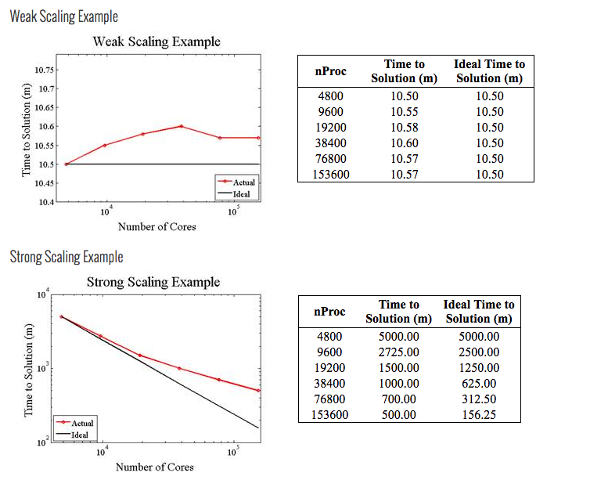

Precision reported
One of: single precision, double precision, mixed precision. Only the precision you use in the simulation is relevant.
<Enter your text here>

Time-to-solution
The normalized time-to-solution averaged per iteration
$$T_{i}^{*}=\frac{t_{i}∙N_{c}}{N_{e}}$$
AND the normalized total time to solution
$$T_{f}^{*}=\frac{t_{f}∙N_{c}}{N_{e}}$$
with $t_{i}$ the time per iteration, $t_{f}$ the total time to solution, $N_{c}$ the number of cores and $N_{e}$ the number of computational elements (size of the problem).
IMPORTANT: Justify the choice of your code (e.g., comparison with existing codes, methods or any other scientifically rigorous argumentation). See also the text referring to Preparatory Access in the Important Notice at the top of Page 1.
<Enter your text here>

System scale
One of: results measured on full-scale system, projected from results of smaller system, other (specify).
<Enter your text here>

Measurement mechanism
One of: timers, FLOP count, static analysis tool, performance modelling, other (specify).
<Enter your text here>

Memory usage
Specify requirements per node or core depending on the size of the problem.
<Enter your text here>

OPTIONAL: Percentage of available peak performance
Please collaborate with the Centre on obtaining this information (see also the text referring to Preparatory Access in the Important Notice at the top of Page 1). Alternatively provide code specific metrics for the requested machine (FLOPS, etc.).
<Enter your text here>

Please visit the following link for a better overview of the Job Report:
https://confluence.cscs.ch/spaces/KB/pages/862946109/Batch+Job+Summary+Report#BatchJobSummaryReport-DownloadingtheExecutable

Milestones (quarterly basis) (Maximum 1 page)
Goals and milestones should articulate simulation and developmental objectives and be sufficiently detailed to assess the progress of the project. It is especially important that you provide clear connections between the project's overarching milestones, the planned production simulations, and the compute time expected to be required for these simulations. Please clarify any dependencies of milestones on other milestones. Please ensure that the node hour consumption follows CSCS quarterly allocation to distribute resources.

Gantt Chart
Provide a Gantt Chart of the simulation plan in production indicating job sizes and scheduling of computing tasks.
<Enter your text here>

Previous Allocations and Results (~1/2 page)
Please specify previous Tier-0 allocations and relevant results. Any results of relevance to the project need to be listed to demonstrate how the proposal contributes to the long-term goals of the proposer. Research publications and reports that resulted from previous allocations should be listed in the References below.
<Enter your text here>

References (Maximum 30)
Please do not provide self-references. Those should go in the PI’s list of publications.

<Enter your text here>

Appendix 1: Track Record of the PI

Granted patents and other measures for the relevance of the work
<Enter your text here>

Prior allocation history in PRACE, national calls, as well as international programs such as INCITE of the US DoE
<Enter your text here>

Participation by team members in other European Commission (EC) actions, such as ERC or Marie Skłodowska-Curie EC grants, etc.
<Enter your text here>

Appendix 2: Technical information

Partition name: LUMI-G or Alps
Code used:
Requested amount of resources in GPU hours:
Number of jobs simultaneously:
Wall clock time of a typical job execution (h):
Are you able to write checkpoint? :
Maximum time between 2 checkpoints (h):
Minimum # nodes:
Average # nodes:
Maximum # nodes:
Minimum job memory (total usage over all nodes GB):
Average job memory (total usage over all nodes GB):
Maximum job memory (total usage over all nodes GB):
Maximum amount of SCRATCH needed at a time (GB):
Maximum amount of PROJECT needed at a time (GB):
Maximum amount of HOME needed at a time (GB):
Maximum # files to be stored on SCRATCH (thousands):
Maximum # files to be stored on PROJECT (thousands):
Maximum # files to be stored on HOME (thousands):
Total amount of data to transfer to/from (GB):
Justification of data transfer:

Development
Development of the codes:

Dissemination Strategy
Dissemination strategy:

Collaboration and Funding
Is any part of the project covered by confidentiality? :
Additional funding EC (ERC, Marie Curie, etc):
International collaboration:
National funding:
Other funding:

